# Onco*E6TM* cervical test Kit Fact sheet

**Principle of the test**

The OncoE6™ Cervical Test uses cell lysates generated from cervical (tipped polyester) swab specimens or from specimens collected in PreservCyt® solution (cervical PreservCyt® specimen). The lysate is incubated with alkaline phostphatase (AP) conjugated high-affinity monoclonal antibodies (mAbs) to E6 oncoprotein of HPV subtypes 16 and 18 (E6 16/18). A nitrocellulose test strip, with two capture lines (consisting of immobilized mAbs to E6 16/18), is placed into the specimen lysate/mAb-AP mix. This mix migrates through the test strip membrane by capillary action. A ternary complex (capture mAb-E6-detector mAb) may form if the E6 oncoprotein of HPV types 16 and/or 18 is present in the mix. Upon addition of an enzyme substrate, the ternary complex becomes visible as a purple line at the respective locations (E6 of HPV subtype 16 or 18) on the strip. The result is positive if the test is valid and a purple test line of any intensity can be visualized; the result is negative if no test line is present on a valid test.

**Introduction**

Cancer /neoplasm/ is one of the most lives threatening challenge worldwide. It can be happed due to different exposure including infection, radiation or unknown causes. Among the reported cases 15 -20% of cancers are caused by viral infections. Human papillomaviruses (HPVs) are one of the carcinogenic virus and responsible for approximately 5% of all cancers. It contribute almost all cervical cancer cases.

HPV cause cancer with its product of oncogenic proteins E6 and E7 produced from specific gene locus called E6 and E7 gene of HPV. Understanding of this oncogenic proteins are leading to the way of diagnosis and treat the cancer related to HPV.

Currently there are different type off screening/diagnosis/ approach which include HPV DNA testing, oncogenic protein encoded mRNA test, Oncogenic proteins test, cytological/ histologic based test.

The OncoE6TM Cervical Test is a qualitative test that detects elevated levels of E6 oncoproteins expressed from cells infected by the Human Papillomavirus types 16 and / or 18.

Detection of elevated levels of E6 oncoprotein in cells from cervico-vaginal specimens indicates an existing precancerous or cancerous lesion, or elevated risk of future precancer or cancer.

**Facts of HPV**

The HPVs are a group of virus grouped under the family of papillomaviridae which characterized as small non-enveloped circular double stranded DNA viruses, measuring 50–55 nm in diameter. Papillomaviruses includes 300 different genotypes based on nucleotide sequence comparison of the L1 Open Reading Frames (ORFs), among which 200 of them are known to be detrimental to human kind.

Among the 200 HPV types 14 are potentially carcinogenic type of HPV and known as high risk group. Among 14 types HPV 16 and 18 account more than 80% of total cervical cancer.

**Facts** 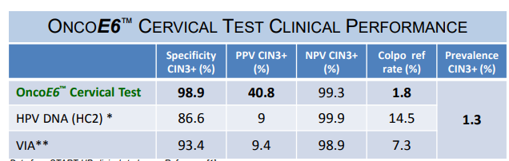

Onco*E6TM* cervical test

Simple

* Sample collected with a swab
* Tests can be conducted in the physician office
* Simple test format, easy and clear visual readout
* Minimal equipment required
* Dipstick format – easy to use
* Same day results

Easily Adaptable

* No need of extra instrument installation
* No need of sophisticated training and martials
* Can be perform even a place with no electric supply
* Short TAT for result ~ 2.5hrs
* Cost effective